Dr. SAMALA NAGARAJ
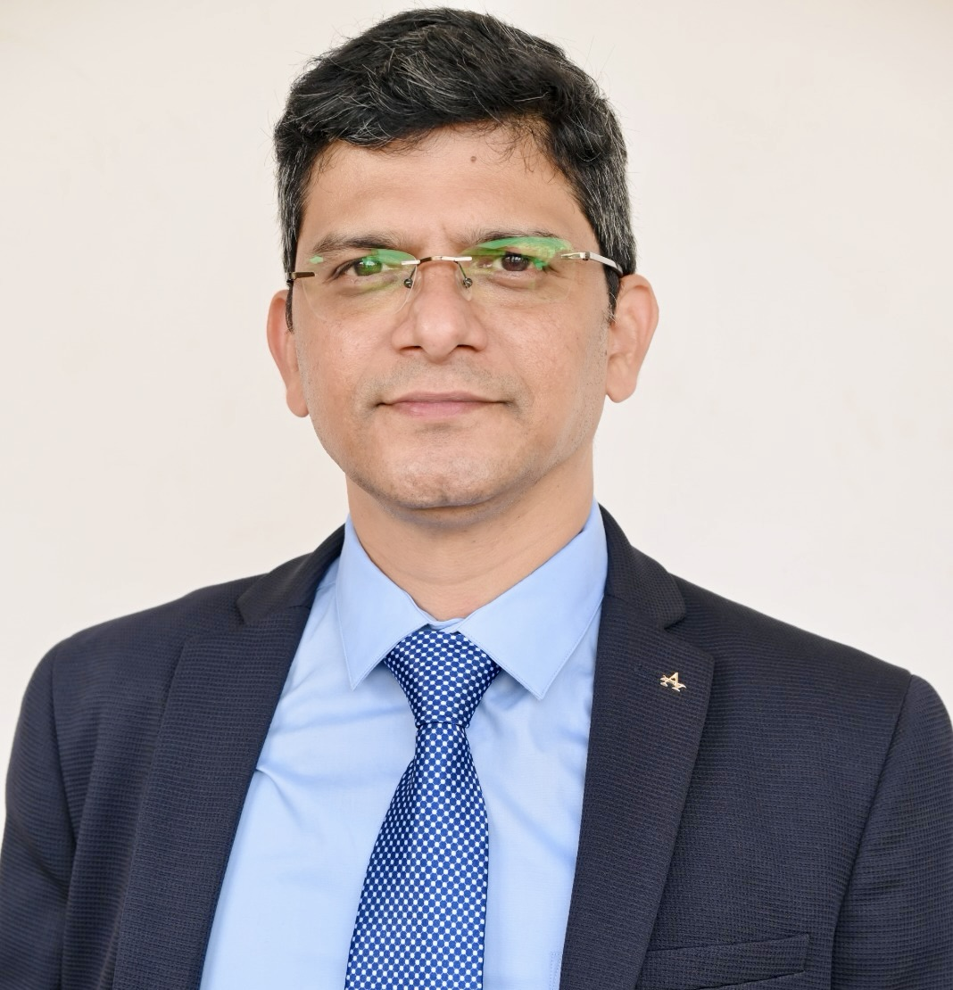
E-mail: raajsamala.phd@gmail.com, Mobile: +91 9160002814
Academic Philosophy & Strengths:
If we are teaching today’s learners like yesterday, we are spoiling their future.
Forward Thinking | Administration | Research | Accreditations | Collaborations | Communication | Teams
Professional Summary:
- A total of 23 years of administration + research + teaching experience.
- 18 years of experience in teaching Marketing & Analytics. 5 years of research (PhD) experience.
- Successfully spearheading a New B-School for Women as founding Dean for the last 3 years.
- Pursuing Graduate Certificate in Marketing & Digital Strategy from HARVARD UNIVERSITY.
- Secretary – Telangana Chapter of Association of Indian Management Schools (AIMS)-2025-26
- Accepted a paper to present at the AMS Conference in May 2023, USA.
- Program Director for Executive MBA at Woxsen University (2020-21).
- Chair – University Research & Development (R&D) at Woxsen University.
- Scopus H-index is 9 with over 40+ articles and 1600+ citations. 2 Edited Books
- Published research papers in SSCI, ABDC – A, B & C, Scopus and Q1 (Eight) indexed journals.
- Guest Editor for Special Issue in Journal of Consumer Behaviour (ABDC-A) indexed.
- Outstanding Paper Award by Emerald Literate for the year 2023
- Proficiency in statistical software like SPSS, AMOS, Python, Tableau & AI
- Qualified UGC-JRF (Junior Research Fellowship) in Management in December 2012
Work Experience:
Dean & Professor | School of Innovation & Management (SoIM), Hyderabad  (Pulla Reddy Educational Group) | Currently Working  September 2022 – till date.
Associate Dean (MBA),  Chair – University R&D  Director – Executive MBA | Woxsen University, Telangana | 2 years and 8 months  December 2019 – August 2022.
Associate Professor | ICBM – Business School, Hyderabad | 6 months  July 2019 – December 2019.
Ph.D. Marketing | University of Hyderabad  (UGC-NET & JRF) | 5 years  July 2014 – January 2020.
Assistant Professor | K G R I T M  (Osmania University) | 5 years  June 2009 – May 2014.
Assistant Professor | Holy Mother P G College  (Osmania University) | 4 years and 6 months  November 2004 – April 2009.
Education:

- Pursuing Graduate Certificate in Marketing & Digital Strategy from Harvard University.
- Ph.D. (Marketing) from University of Hyderabad in 2019
- M.B.A. (Marketing) from Kakatiya University in 2004
- B.Sc. (Mathematics, Statistics, Computer Science) from Osmania University in 2002

Current Roles & Responsibilities @ School of Innovation and Management (GNITS)
- Build a New Business School (for Women) from scratch.
- Onboard Advisory, BoS, and Governing Body Members of academic and industry repute.
- Comply, communicate, and administer AICTE regulations.
- Partner and sign MoUs with international universities for student exchange programs.
- Partner and sign MoUs with corporates for student internships, Placements, and Projects.
- Conduct regular BoS, Advisory & Governing Body meetings.
- Strategize and manage social media promotions and create visibility.
- Monitor the Marketing and Admission team and their activities.
- Design, Implement & Manage Academic and Curricular activities.

Achievements at School of Innovation and Management (SoIM)
- Established New BSchool for Women and successfully convocated 1st batch (2023-24).
- Two successful students’ Global Immersion Program for student; Malaysia and Dubai.
- 14+ MoUs with International Universities for student exchange programs.
- Directed 85% campus placements with highest 14 LPA package.
- Onboarded companies like ITC, Deloitte, Himalaya, RyanTax, Berkaria, Factset etc.
- Established new age curriculum with advanced certifications for students.
- Partnered with institutions like PMI, NISM, BISF, IIBA, & Bloomberg for certifications.
- Successfully attained of Extension of Approvals (EoA) from AICTE.
- Built strong academic, marketing and Training & Placement teams.
- Strategic planning for Branding, Marketing and Admission Campaigns.
- Awarded “Outstanding Business School” at FutureEd Summit-2025, June.
- Created outstanding visibility for SoIM through digital strategy and online presence.
Roles & Responsibilities at Woxsen University
- Creation and dissemination of corporate-induced/practice-oriented research at university.
- Engagement with corporate through the materialization of MoUs for collaborative programs, research, and other activities.
- Nurture and develop research culture through various events, activities, & collaborations.
- Ensure corporate alignment and integrated research among all the faculty.
- Ensure quality research output across university year-on-year.
- Align research activities & output with the objectives of AACSB, EFMD & RRBM.
- Collaboration/MoUs with international universities for various exchange activities.
- Ensure high-quality usage and implementation of technological tools in the delivery of modules and corporate connect.

Achievements at Woxsen University
- Setup an Electric Research Lab by signing an MoU with Ermin Automotives
- Discussions with Tech Mahindra and TCS for setting up Research Labs
- Procured 6 consultancy projects worth 15 lakhs in the last year
- Streamlined Research Centres & Committees at the University level for significant output
- Played a major role in the successful launch & execution of PhD program
- Core Committee member of Business Analytics program
- Active member and chairperson for two Centre of Excellence
- Successfully ran 2 research projects with PECS University, Hungary & FIA, Brazil
- Received “Academic Excellence” award in the year 2021-22

Teaching:
- Fundamentals of Data Analytics for Post Graduate Students at BEM, Dakar (30 hours)
- Business Analytics for BBA at United International University, Bangladesh (45 hours)
- Advanced Business Analytics for MBA at United International University, Bangladesh
- Strategic Marketing Management for 2nd Year MBA at Woxsen University
- Business Statistics, and Advanced Analytics for MBA at Woxsen University
- Marketing Analytics & Big Data using Python for MBA at Woxsen University
- Data Visualization using Tableau for PGDM at Woxsen University
- Business Research Methods – 1 for MBA at Woxsen University
- Business Research Methods – 2 for MBA at Woxsen University

Papers Published:
- Samala Nagaraj (2026). Consumer trust in sustainable seafood certification agencies: A comparative study across twelve markets. Sustainable Futures. 130, 105538. (ABDC-C, Scopus, Q1)
- Samala Nagaraj (2025). Consumer preferences for seafood sustainability attributes: A comparative study of 12 markets. Food Quality & Preference. Early-to-cite. (ABDC-A, Scopus, Q1)
- Samala Nagaraj (2021). Role of consumer health consciousness, food safety & attitude on organic food purchase in emerging market: A serial mediation model. Journal of Retailing and Consumer Services. 59, 1-8. (SSCI, ABDC-A, Scopus, Q1)
- Bharath, Ramulu, Samala Nagaraj (2021), Longitudinal analysis versus Cross-sectional analysis in assessing the factors influencing Shoppers’ Impulse Purchase Behavior – Do the store ambience and salesperson interactions really matter? Journal of Retailing and Consumer Services.
61. (SSCI, ABDC-A, Scopus, Q1)
- Samala Nagaraj, Ahmed, S., and Singh, S. (2024), "What do online reviews communicate? An evidence from emerging economy", International Journal of Emerging Markets, Vol. 19 No. 10, pp. 3483-3512. https://doi.org/10.1108/IJOEM-06-2021-0892. (ABDC-B, Q2)
- Samala Nagaraj, & Bharat Shashanka. (2019). Fashion Brands are engaging the Millennials: A moderated-mediation model of Customer-Brand Engagement, Participation, and Involvement. Young Consumers. 21(2), 233-253. (ABDC – B, Scopus, Q1)
- Samala Nagaraj, & Sapna Singh. (2018). Millennial’s engagement with fashion brands: A moderated-mediation model of brand engagement with self-concept, involvement and knowledge.
Journal of Fashion Marketing and Management: An International Journal, 23(1), 2-16. doi: https://doi.org/10.1108/JFMM-04-2018-0045. (ABDC – B, SSCI, Scopus, Q1)
- Dasari, Ramanjaneyulu, Nagaraj. (2020). A Study on Consumers Motivations towards Organic
Food Products in India. Academy of Marketing Studies Journal, 24(2). 1-8. (ABDC – B, Scopus)
- Nagaraj Samala, Sapna Singh, Rhulia Nukhu, & Mansi Khetarpal (2019). Investigating the Role of Participation and Customer-Engagement with Tourism Brands (CETB) on Social Media. Academy of Marketing Studies Journal, 23(1). 1-16. (ABDC – B, Scopus)
- Vinay, Samala Nagaraj, Raja Shekar. (2021). Heritage Hotels & Customer Experience: A Text Mining Analysis of Online Reviews. International Journal of Culture, Tourism, and Hospitality Research. (ABDC – B, Scopus)
- Samala Nagaraj, Sapna Singh, & Soumya Singh. Factors affecting consumers’ willingness to subscribe to Over-the-Top (OTT) video streaming services in India: A Logistic Regression analysis. Technology in Society. (ABDC – C, Scopus, Q1)
- Samala Nagaraj, Bharat Shashanka, Raja Shekar, Raul Roudriez. Impact of AI and Robotics in the Tourism sector: A Critical Insight. Journal of Tourism Futures. https://doi.org/10.1108/JTFhttps://doi.org/10.1108/JTF-07-2019-006507-2019-0065 (ABDC-B, Scopus, Q1)
- Samala Nagaraj, & Sapna Singh. (2018). Investigating the Role of Customer Brand Engagement and Relationship Quality on Brand Loyalty: An Empirical Analysis. International Journal of EBusiness Research (IJEBR), 14(3), 34-53. (ESCI, Scopus)
- Samala Nagaraj, & Sapna Singh. (2017). Investigating the Mediating Role of Customer ESatisfaction on E-Service Quality and E-Loyalty: An Empirical Evidence of Indian Online
Shopping. International Journal of Economic Research, 14(15), 623-633. (Scopus)
- Sateesh Kumar and Samala Nagaraj. (2021). Applications of Artificial Intelligence on Customer Experience and Service Quality of the Banking Sector. International Management Review. 17(1). 9-17. (UGC-Care Listed)
- Samala Nagaraj (2021). Detection of Casava Plant related Diseases using Deep Learning. International Research Journal of Plant Science. DOI: 10.14303/irjps.2021.16 (UGC-Care Listed)
- Katarzyna Żyminkowska, Samala Nagaraj, & Edyta Gołąb-Andrzejak. (2019). Customer Engagement Consequences for Firms. Journal of Emerging Trends in Marketing and Management. www. http://www.etimm.ase.ro/
- Samala Nagaraj (2019). AI enabled Marketing: What is it all about? International Journal of Research, 8(6), 501-518.
- Samala Nagaraj. Marketing Analytics for Customer Engagement: A Viewpoint. International Journal of Information Systems and Social Change. 11(2), IGI-Global
- Nagaraj, S. (2018). Application of TAM and the role of gender in adopting mobile apps for shopping: An empirical analysis. Asian Journal of Multidimensional Research (AJMR), 7(9), 4352.
- Lakshmi, S. V., & Nagaraj, S. (2018). Factors affecting customers’ willingness to purchase organic food in India: A logistic regression model. Asian Journal of Multidimensional Research (AJMR), 7(11), 366-373.
- Nagaraj, S., & Vijayalakshmi, S. (2018). A study on food ordering mobile apps. Asian Journal of Research in Social Sciences and Humanities, 8(7), 10-23.
- Samala Nagaraj, & Sapna Singh. (2017). Adoption of Internet Banking Services in India: An Empirical Study. Global Journal of Management and Business Research, 17(2), 37-42.
- Kalyani Anumala, & Samala Nagaraj. (2017). Impact of Supply Chain Management Practices on Product Quality in Indian Handloom Industry with reference to Master Weavers. International Journal of Advanced Research, 5(6), 1-10.
- Samala Nagaraj, & Sapna Singh. (2015). Consumer Engagement: An Emerging Marketing Tool. International Research Journal of Commerce, Business and Social Sciences, 4(6), 164-168.

Papers under Review:
  - The Influence of Shopping Motives on Retail Website-Customer Engagement: An Empirical Analysis of Online Purchase & Engagement Behavior. Journal of Product & Brand Management. (ABDC-A).
  - Moderating role of Customer-Brand Engagement on Image Clarity, Participation & Advocacy relationship: A study of Fashion Brands on Twitter. Journal of Retailing and Consumer Services. (SSCI, ABDC-A, ABS-2).
  - Demystifying Hospitality & Consumer Service Complaints: A Quantitative and Qualitative Analysis of Consumer Online Reviews on Heritage Hotels. Journal of Hospitality and Tourism Management. (SSCI, ABDC-A, ABS-2)
  - Samala Nagaraj. Applications of Machine Learning in the Understanding of Consumer Behavior: A Viewpoint. Foresight. (ABDC – C, Scopus)

Research Work-in-Progress:
  - Investigating the role of Customer Engagement and Trust with Travel & Tourism Brand on Social Networking Sites in India
  - Role of Customer Engagement on Image, Advocacy and Participation with Fashion Brands on Twitter.
  - Environmental Consciousness and Consumer Purchase Intentions of Green Fashion products.

Ph.D. Thesis:
Title: “Customer-Brand Engagement with Fashion Brands through Online Brand Communities in India: A Multimethod Approach”

Book Editor:
Title | Indexed | Publisher | Status
Insights, Innovation, and Analytics for Optimal Customer Engagement | Scopus | IGI Global,  USA | Published
AI-Driven Intelligent Models for Business Excellence | Scopus | IGI Global,  USA | Published
Book Chapter(s):
Book Title | Chapter Title | Publisher | Editor(s)
Customer Engagement by  Fashion Brands: An  Effective Marketing Strategy | Handbook of Research on Circular  Economy and Re-Commerce in the Fashion Industry | IGI  Global,  USA | Prof. Archana,  Prof. Geetika Jain, Prof. Justin Paul
Big Data Analytics | Market Basket Analysis | Taylor & Francis  (Scopus) | Prof. Kiran Chaudhary & Prof.  Mansaf Alam
AI-Driven Intelligent Models for Business Excellence | Business Tech in Media and Entertainment | IGI  Global,  USA | Dr. Nagaraj Samala and Dr. K.V. Rajesh

Workshops/FDPs (Conducted/Delivered):
Type | Theme/Title | Institution | Date
FDP | Research Data Analysis using R programming | Woxsen University, Hyderabad | 22nd & 23rd January, 2022
Workshop | The Art of Publication | Woxsen University, Hyderabad | 26th & 27th March, 2022
FDP | Qualitative Research Using Python Programming | Woxsen University, Hyderabad | 13th , 14th ,  20th & 21st May, 2022
2-week Workshop | Research Methodology | Islamic University of Science & Technology | 21st Feb to 4th March, 2022

Conferences (Conducted as a Convenor):
Type | Theme/Title | Institution | Date
International Conference | Artificial Intelligence & Knowledge Processing 2021 | Woxsen University, Hyderabad | 24th April, 2021
International Annual Conference | DigITS: Digitalization, Innovation  Transformation and Sustainability | Woxsen University, Hyderabad | 27th & 28th November, 2021
International Annual Conference | DigITS: Digitalization, Innovation  Transformation and Sustainability | Woxsen University, Hyderabad | 29th & 30th October, 2022

Keynote Speaker:
Type | Theme/Title | Institution | Date
International Conference | Fostering Resilient Business Ecosystems and Economic Growth: Towards the Next Normal | Dr. D. Y. Patil B-School, Pune, India | 27th – 29th April, 2022
International Conference | International Conference on Data Analytics in Business and Marketing | Shivaji College, University of Delhi | 21st & 22nd April, 2022

Reviewer/Editorial Board Member:
Journal | Publisher | Indexed
Information Technology & Tourism | Springer | ABDC-B, Scopus
Journal of Fashion Marketing & Management | Emerald | ABDC-B, Scopus
Young Consumers | Emerald | ABDC-B, Scopus
Journal of Electronic Commerce in Organizations | IGI Global | ABDC-B, Scopus
International Journal of Retailing & Consumer Services | Elsevier | ABDC-A, Scopus
International Journal of Innovation and Technology Management | W Scientific | ABDC-C, Scopus
International Journal of E-Business Research | IGI Global | Scopus

Conferences/Paper Presentations:
  - “Customer Engagement Consequences for Firms”, Emerging Trends in Marketing & Management-ETiM&M-2019”, conducted by Bucharest University of Economic Studies, Romania, Europe, September 26th – 28th, 2019.
  - "A Study on Food Ordering Mobile Apps", National Conference on Digital Commerce Opportunities and Challenges, conducted by Telangana Commerce Association, 7th April, 2018, Hyderabad.
  - "Customer Engagement on Social Media by Tourism Brands in India: An Empirical Analysis, National Conference on Growth Strategies of Tourism in India: Opportunities & Challenges, conducted by Central University of Punjab, 29th & 30th November, 2017, Bhatinda.
  - "Investigating the Role of Customer Satisfaction in Online Shopping in Indian Context", 7th IIMA Conference on Marketing in Emerging Economies, conducted by Indian Institute of Management-Ahmedabad, 11th - 13th January, 2017, Ahmedabad.
  - "Consumer Brand Engagement in India-A study of select Online Websites, 9th Doctoral Thesis Conference, conducted by ICFAI Business School, 21st & 22nd April, 2016, Hyderabad.
  - "Exploring the Conceptualization of Consumer Engagement", 5th Annual International Conference on Sustainability - SUSCON-5, conducted by Indian Institute of Management Shillong, 17th - 19th March, 2016, Shillong.
  - "Consumer Engagement: An Emerging Marketing Tool", International Conference on Issues and Challenges, Humanities and Social Sciences, conducted by SSPES's Goa Multi Faculty College, 17th & 18th October, 2015, Goa.
  - "Case Study is an Effective Technique in Modern Teaching Methods", 2 Week SDP on Modern Teaching Techniques in Management, conducted by Global Education Center, 25th April - 8th May, 2012, Hyderabad.
  - "Self-Assessment in Performance Evaluation", 3 Day National Seminar on Strategic Quality Management through Innovation and Value Creation, conducted by University of Hyderabad, 18th - 20th March, 2010, Hyderabad.
Workshops/FDPs (Attended):
Type | Theme/Title | Institution | Date
Workshop | Systematic Review and Meta-Analysis | Campbell Collaboration  & University of  Hyderabad | 5th – 7th Feb,  2018
Workshop | Publishing Quality Research Papers | IIM, Ahmedabad | 11th Jan, 2017
Workshop | Research Methods in Marketing | Great Lakes | 26th Dec – 30th  Dec, 2016
FDP | Statistics with R | National Institute of  Technology | 26th Nov – 1st  Dec, 2016
FDP | How to get your Research published in High Impact Journals | Narsee Monjee Institute of Management Studies | 25th – 26th June, 2016
PDP | Statistical Packages | Maulana Azad National Urdu University | 14th – 19th Sept, 2015
FDP | Workshop on Business Analytics Techniques for Decision Making | M.A.M. College of  Engineering &  Technology | 23th – 6th Feb,  2015
Workshop | Multivariate Analysis using Structural Equation modelling | Aurora's P.G. College | 19th – 20th Dec, 2014
Workshop | 6th 7 Day National Workshop on Research methodology for Management and Statistical Analysis using IBM SPSS Statistics 22.0 | ITM University | 8th – 14th Dec,  2014
Workshop | 2 Day Workshop on "Parametric and Non-  Parametric test in Research" | Department of  Commerce, Osmania University | 20th – 21th March, 2014
FDP | Supply Chain Management | Mother Teresa P.G. College | 16th March,  2014
FDP | Effective Teaching through Case Study Methodology | Sreenidhi Institute of  Science and Technology | 13th – 14th July, 2012

Certified Courses:
Course Name | Institute/University | Certificate Number
Managing Data Analysis | Johns Hopkins University | NT5TNS6C3RHR
Marketing Analytics | University of Virginia | NZQQE3KMNEN3
Introduction to Data Analytics | IIT Madras/NPTEL | NPTEL16MG0618360131
Text Mining & Analytics | University of Illinois | UQ33TTTC6XMZ
Customer Analytics | University of Pennsylvania | DDR4YFQDH7QA
Data Science in Real Life | Johns Hopkins University | YT6T4JWJQAKT
Engagement & Nurture Marketing Strategies | Northwestern University | 7F6GFUP8MF59

Other Professional IDs:
Google Scholar | https://scholar.google.co.in/citations?user=BlSMaxz0kJIC&hl=en&oi=ao
ORCID ID | https://orcid.org/0000-0002-1182-115X
Scopus Author ID | 57203587247 (H-index: 09)
ResearcherID | E-6832-2019
Linkedin | https://www.linkedin.com/in/raajsamala/

Personal Details:
Father Name | Late Sri. S.Shankaraiah
Date of Birth | 20th March 1980
Marital status | Married
Languages | English, Hindi, and Telugu
Permanent Address | Plot No.1, Teacher's Colony, Kalyanpuri, Uppal, Hyderabad, Telangana - 39


Place: Hyderabad, INDIA (Dr. SAMALA NAGARAJ)

References:
Details | Reference #1 | Reference #2 | Reference #3
Name  Designation  University  Phone Number  E-mail ID | Prof. B.Raja Shekar  Professor & Ex-Pro VC  University of Hyderabad  +91 98666 99983  brsmsuh@gmail.com | Dr. Amit Bhadra  Former Vice Chancellor  Woxsen University  +91 98675 10185  amitbhadra@hotmail.com | Dr. Rajesh Ittamalla  Professor  IIT, Hyderabad  +91 73868 18382  rajeshittamalla@gmail.com

